## 

## 

## 

## 

## 

## 

Stoic Solutions

## 

## 

## 

## 

## 

## 

## 

Team (stoicsolutionscsusm@gmail.com):

Adam Hebel, Brian Rattanasith, Chris Bertram, Connor Myers,

Enrique Jimenez, Jerry Compton, Jordan Mower, Matthew Adamus

**Table of Contents**

**1. Application Development** 3

1.1 Statement of Business Context 3

1.2 Statement of Customer’s Business Problem 3

1.3 Statement of Project Proposal 3

1.4 Measures of Success 3

1.5 System Overview 4

**2. Requirements Matrix** 5

**3. Project Management** 5

3.1 Initial Schedule for Tasks and Deliverables 5

3.2 Statement of Total Price 9

3.3 Gantt Chart 10

3.4 Initial Project Cost Tracking Chart 13

3.5 Statement of Deliverables 14

3.6 Outline of Resources Needed 14

**Appendix** 15

To: Dr. Kristin Stewart, Assistant Professor of Marketing

CC: Dr. Shaun-inn Wu, Director of Projects

Stoic Solutions is thrilled to be a part of this amazing project for Keep America Beautiful. Thank you, Dr. Stewart, for providing us with this opportunity to be a part of not only a fun and engaging project but also a great cause. We looked forward to continuing our work with you this semester and making this project come to fruition.

The second phase involved the team conducting research and confirming the requirements needed for the database to be created and how the database should be categorized with the UI team. The requirements are as follows: Algorithm will utilize 360 google street images (4 images instead of just 1 or 2), data in database will be defined with a geographic space using longitude and latitude, lastly, data must be available for UI team utilize. In the next phase we plan to dig deeper into the implementation and develop a prototype that identifies a geographical location so that we can have a functional and usable database filled with basic data for the UI team to utilize and begin prototyping the front-end.

Regarding the accrued and projected cost of this project. Our team will be operating at a rate of $28.00 per hour. Our estimated total cost, which includes our hourly rate and the cost of running the AWS server, amounts to $15,869.80 after the actual costs of Phase 1 and 2 have been calculated.

A copy of this report will be submitted to both Dr. Stewart and Dr. Wu

By signing below, you hereby approve Stoic Solutions to continue working on the following project: Keeping America Beautiful: Litter Detective and agree to the aforementioned estimated costs.

Thank you,

Chris Bertram (Project Lead)

stoicsolutionscsusm@gmail.com



Client Signature: ______________________________ Date: ________________________

# **1. Application Development**

## 1.1 Statement of Business Context

Keep America Beautiful is a national non-profit organization that strives to improve, educate, and beautify both the environment and people. With more than 600-community based affiliates, partners, volunteers, and more, they are able to perform just so.

## 1.2 Statement of Customer’s Business Problem

* Keep America Beautiful needs the data produced by the algorithm to mean something.
* Needs the data produced to have a rating system.
* The definition of a geographical space must be defined to signify cities, counties etc.
* Make the data available and usable for the UI team.

## 1.3 Statement of Project Proposal

* Goal 1 - Collect data from 360 Google Street images.
* Goal 2 - Process images through ML.
* Goal 3.1 - Collect output data.
* Goal 3.2 - Define what a geographic space is.
* Goal 4 - Make data accessible to the UI team.

On behalf of Dr. Kristin Stewart we will implement the following with the intent of making this data usable and available to the UI team.

## 1.4 Measures of Success

**JAD 1 -** Identify requirements of the project.

**JAD 2 -** Finalize requirements of the project.

**Prototype 1 -** Able to label and store images for a defined geographic region

**Prototype 2 -** Process images with ML algorithm, produce litter metrics, and delete stored images.

**Final Product** **-** Collation, transfer and storage of litter metrics from GSV360 images that have been processed through a machine learning algorithm for use by UI team.

## 1.5 System Overview

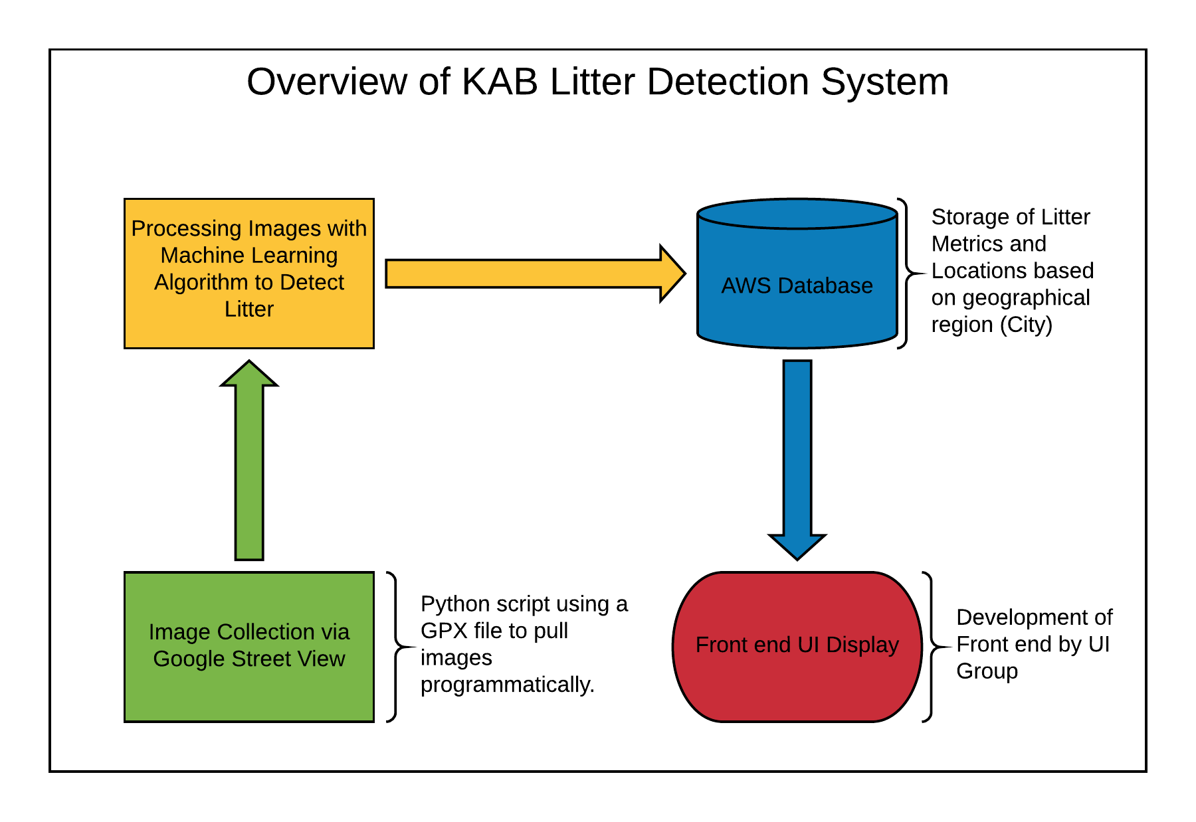

# **2. Requirements Matrix**

|  |  |  |  |  |  |
| --- | --- | --- | --- | --- | --- |
| Req. ID | Requirement | Description | Critical | Implemented [Y/N] | Task ID |
| 1 | Image Collection | - Captured 360 View, Google Maps, Google Street images.  - Python script or student help. | H | N | 5.6, 5.6.1 |
| 2 | Machine Learning Processing | Process images with machine learning algorithm to gather litter metrics. | H | N | 5.6, 5.6.2 |
| 3 | Organize data from algorithm | - Capture data and add it to the database.  - Organized with total litter, litter rating, and geographical location. | H | N | 6.5, 6.5.1, 6.5.2 |
| 4 | Data Accessibility to UI Team | - Litter metrics stored by geographic region for UI team. | H | N | 7.5, 7.5.1 |

# **3. Project Management**

## 3.1 Initial Schedule for Tasks and Deliverables

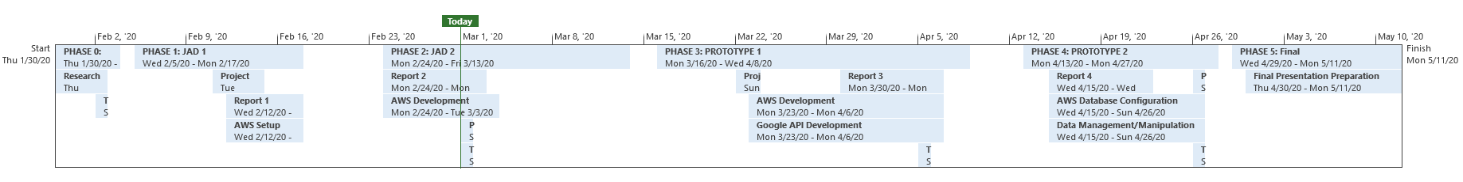

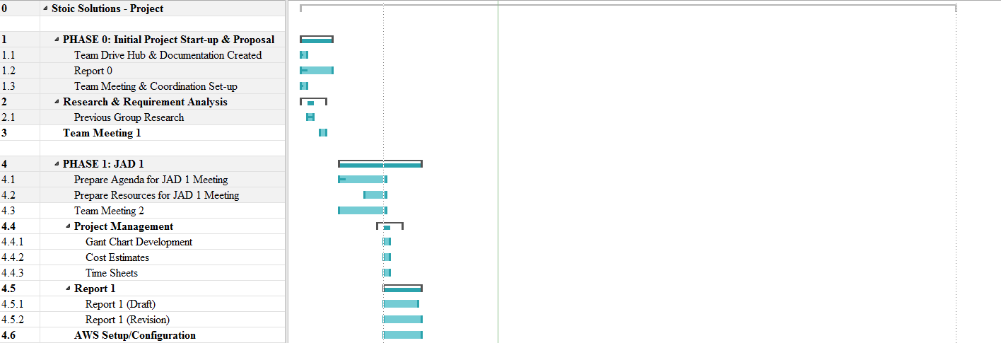

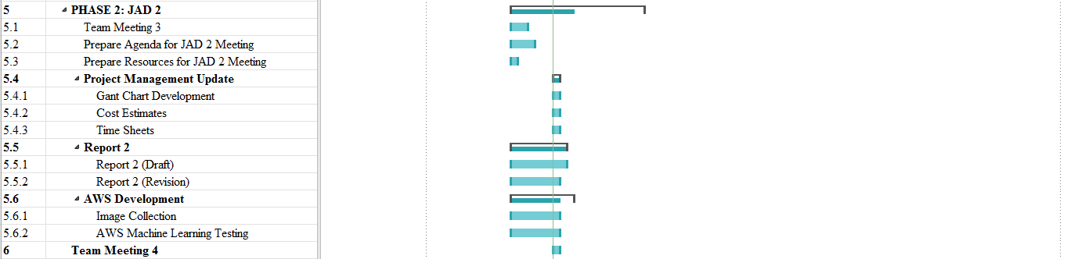

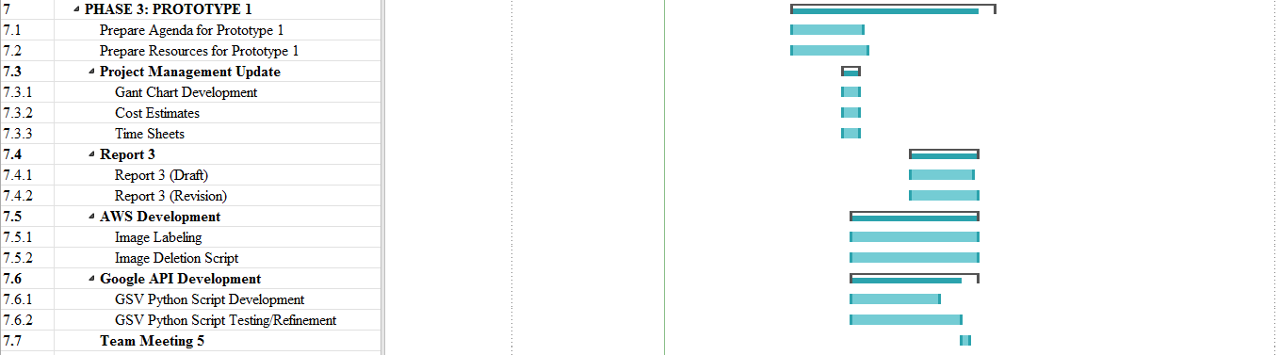

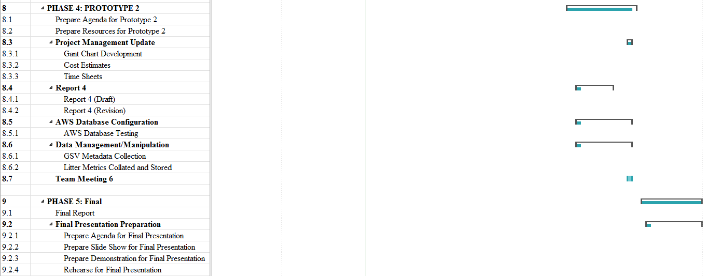

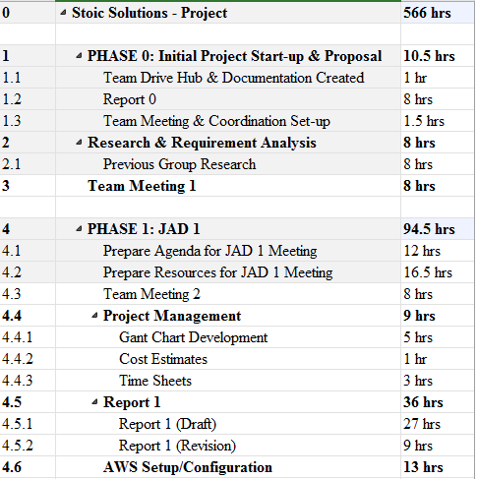

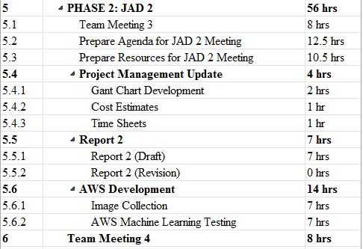

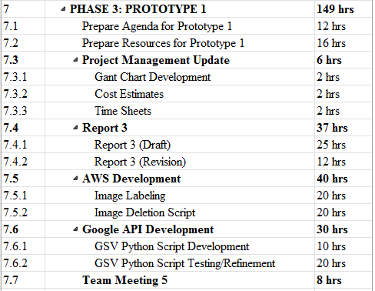

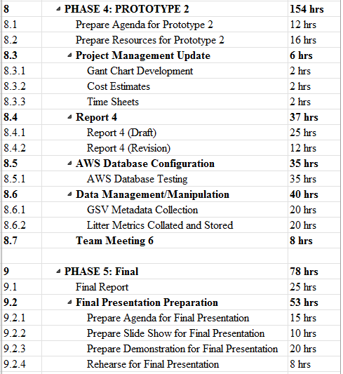

## 3.2 Statement of Total Price

As stated in our initial letter and agreement, the team will be operating at a rate of $28.00 per hour for each member of Stoic Solutions. The AWS server will cost .29 cents per hour to run. Altogether, the estimated cost of the entire project with the actual costs of Phase 1 and 2 calculated is $15,869.80.

## 3.3 Gantt Chart









## 

## 3.4 Initial Project Cost Tracking Chart

Below are the costs accumulated based on the team’s total hours worked. AWS was not configured entirely for Phase 0 & 1 but is represented and accrued at later phases.

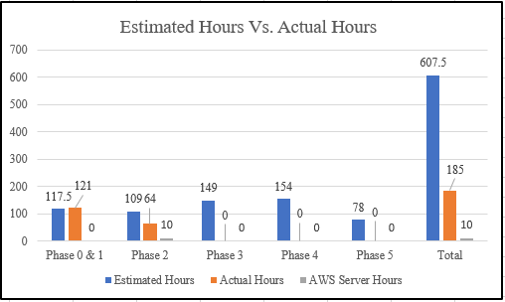

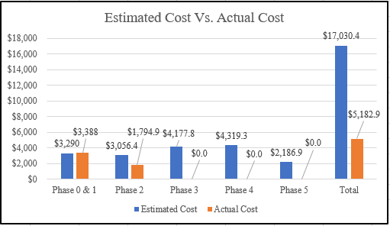

## 3.5 Statement of Deliverables

The Stoic Solutions team strives to deliver the following final products:

* A defined geographic location labelled for each set of 4 images produced from 360 google street images.
* Concise data base filled with litter count in given areas, rating, and geographical location.
* An updated report, including the goals and milestones we’ve reached and all documentation.
* Database documentation and access for UI team to make use of.

The next phase is estimated to cost an additional $4,177.80 for the initial prototype. The prototype will provide images for the defined geographic location which will be used in phase 4.

## 3.6 Outline of Resources Needed

The following resources are what the Stoic Solutions team will be supplying:

* Extensive Knowledge of AWS and database implementation.
* Updated documentation.
* Research and testing.
* Database credentials and access.

The following resources are what the Stoic Solutions team will need supplied from Dr. Stewart:

* Source code from previous team (Machine learning system).
* AWS Server Instance.
* Possible extra student labour to gather images since we will be doing a 360-view requiring 4 images rather than 1.
* Funding.
* Signage and approval for the Stoic Solutions team to continue working on the project.
* Availability for future meetings.

# **Appendix**

**Stoic Solutions Timesheets**

**Week 2:**

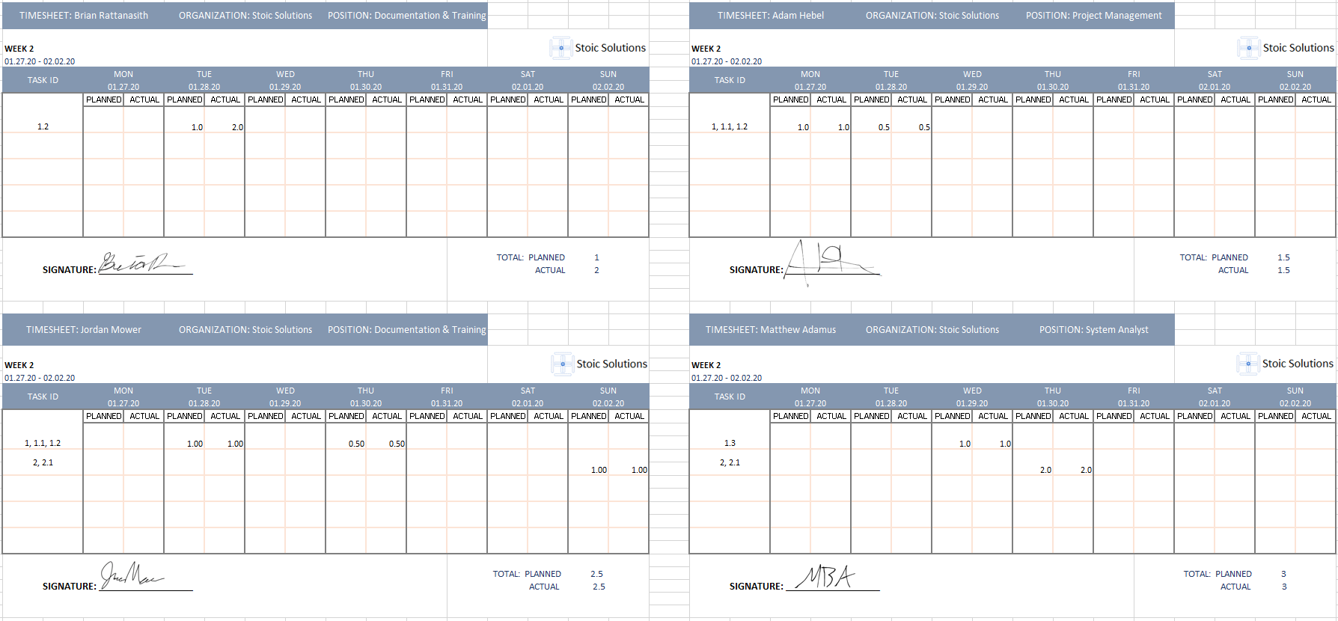

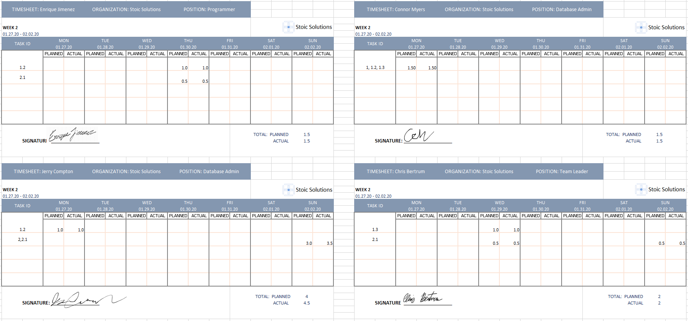

**Week 3:**

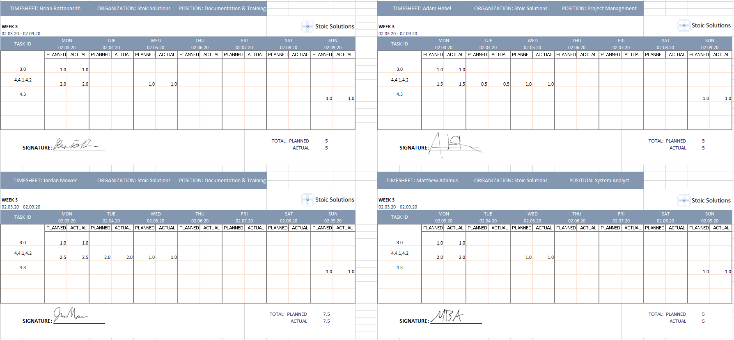

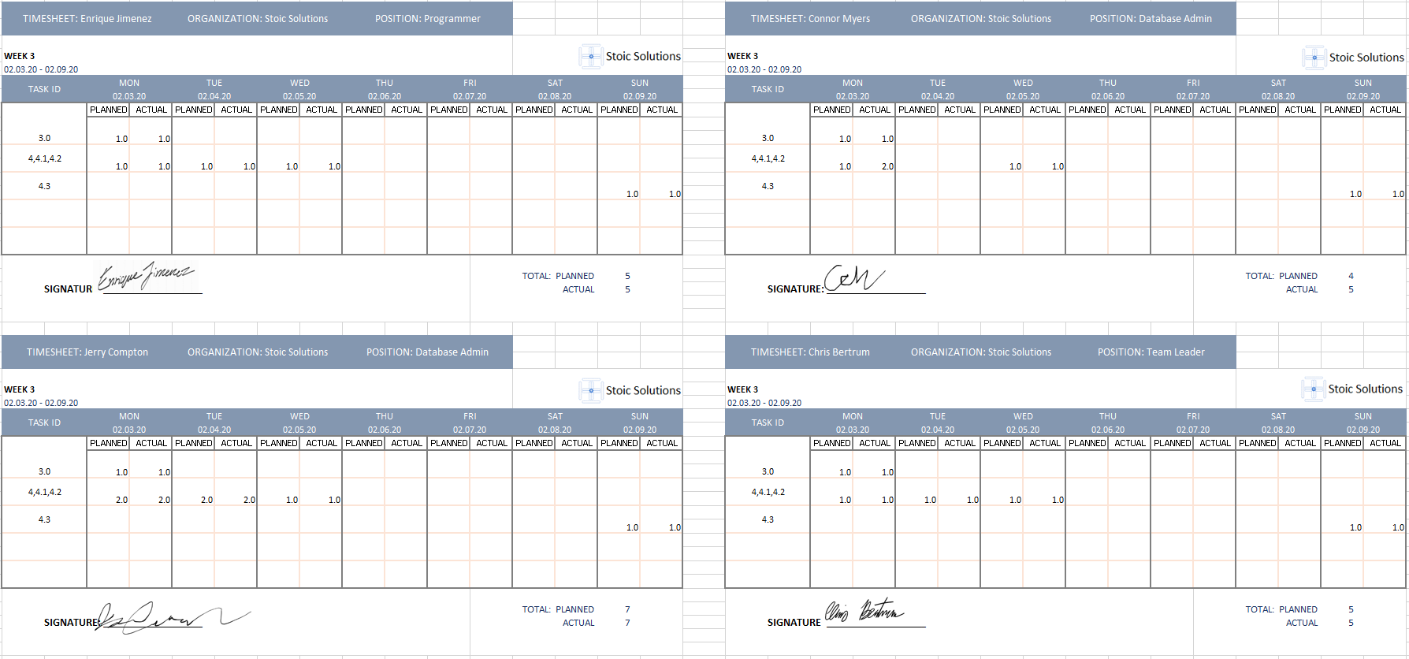

**Week 4:**

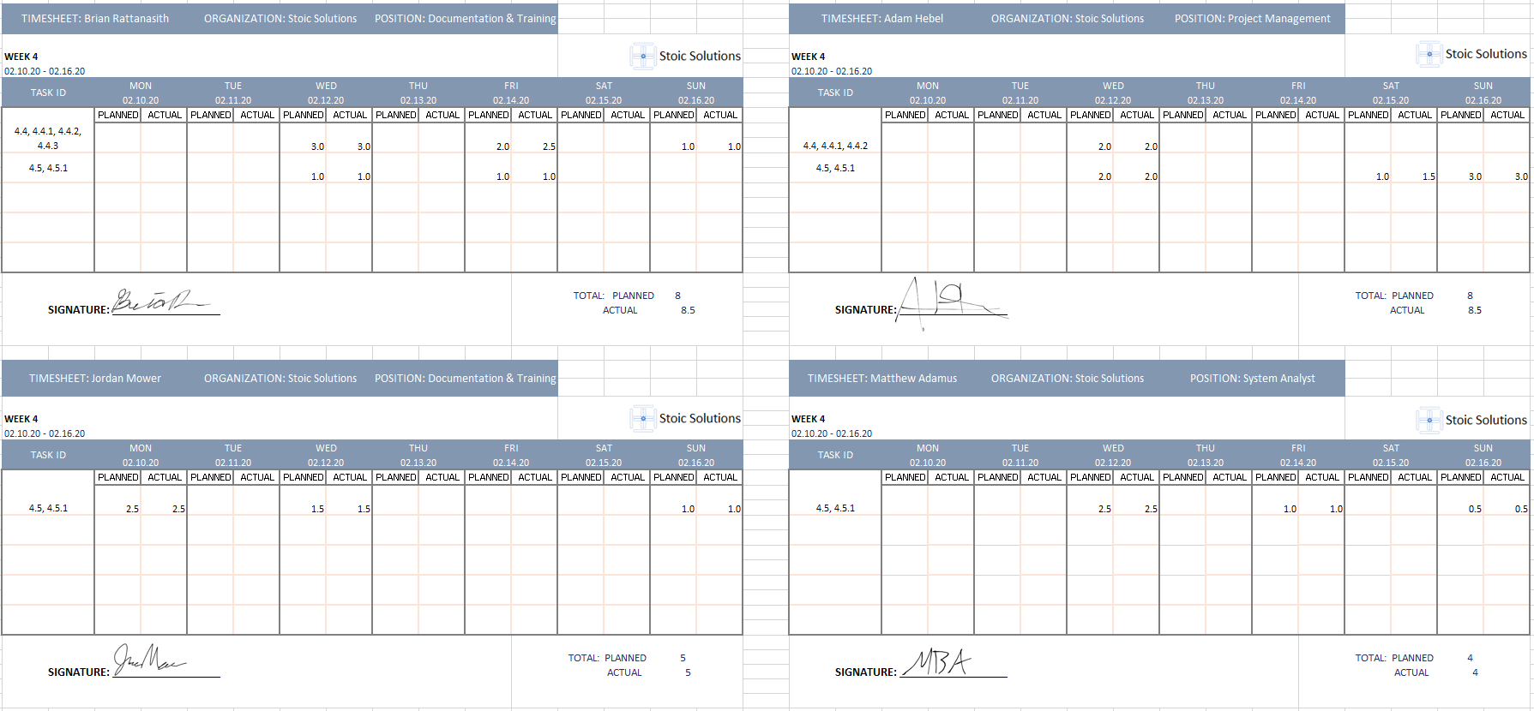

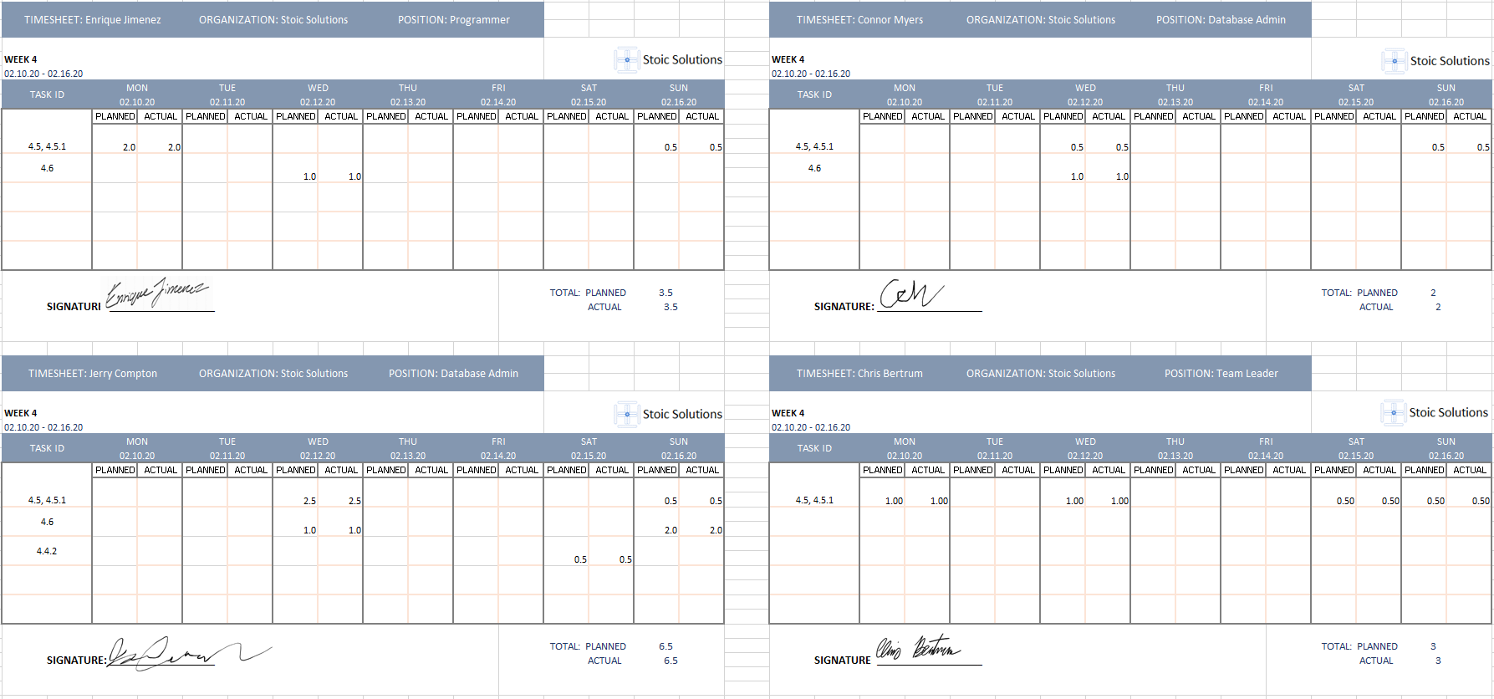

**Week 5:**

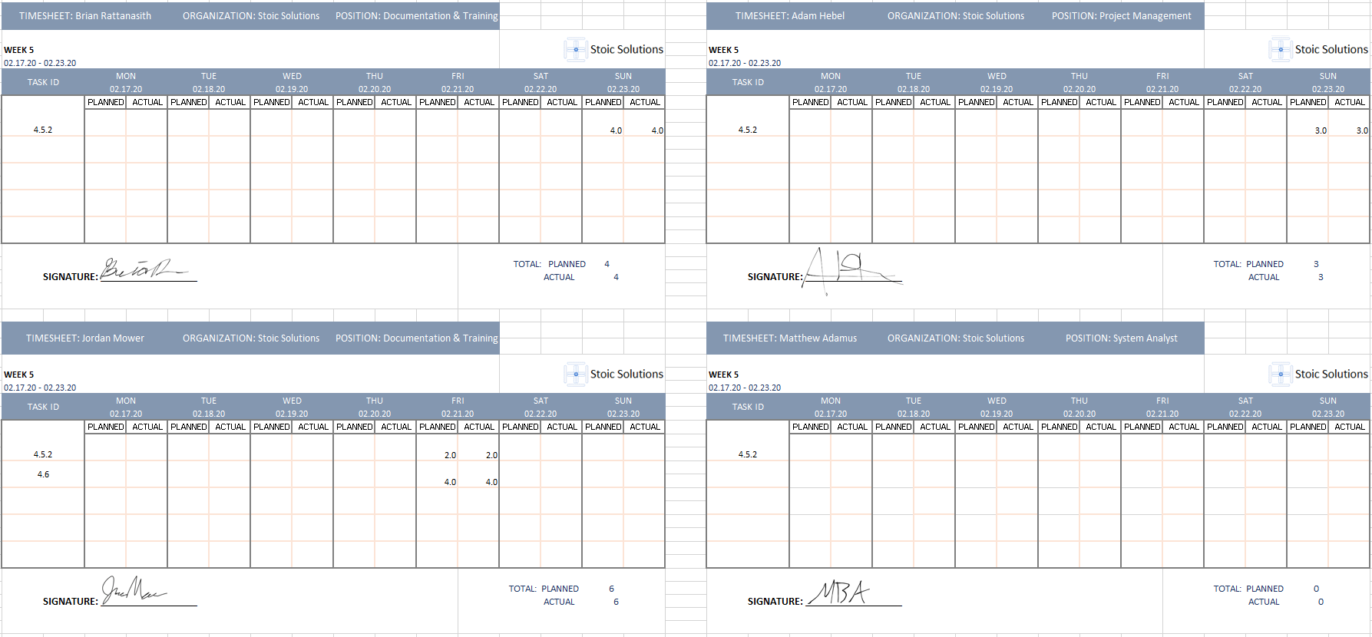

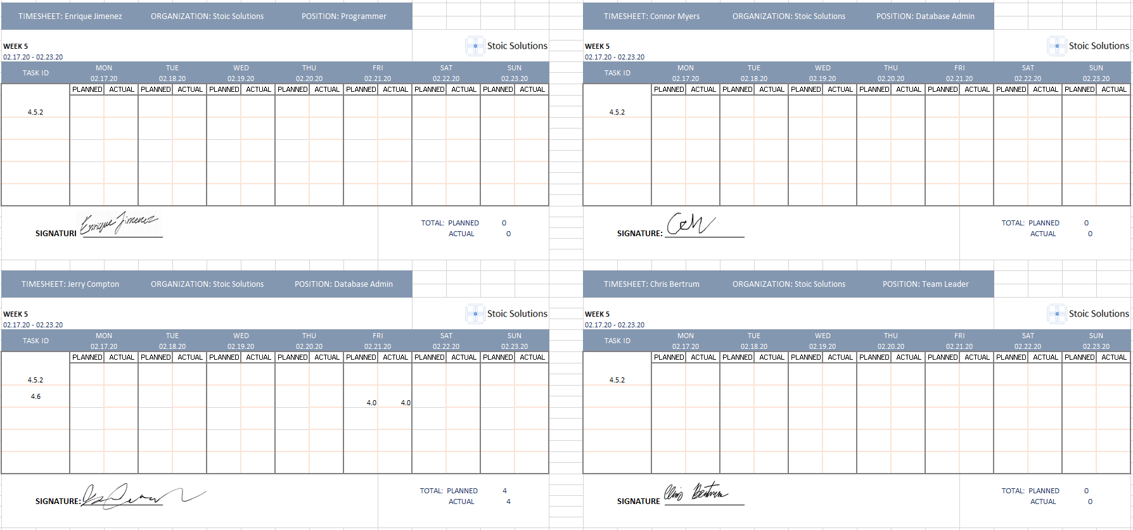

**Week 6:**

